New Library Catalog Coming to InfoSoup Libraries
August ___, 2020
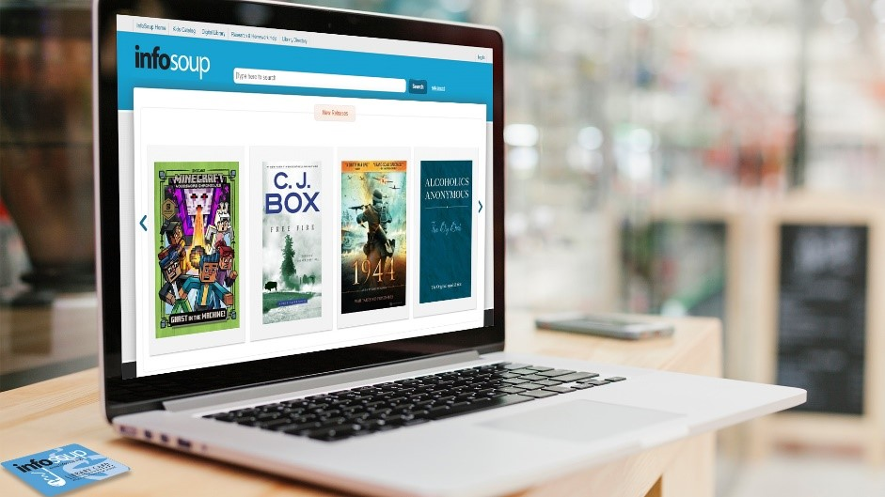
By _____Author_______
InfoSoup is getting a new look! In mid-August, InfoSoup will switch to a new software platform to run and manage its library catalog. “This new system is more cost-effective and efficient and provides a strong foundation for future development,” said Amanda Lee, OWLSnet Manager. The new system will provide a better mobile experience, have less downtime, and offer improved features for finding and managing your library materials.
The infosoup.org address and name will remain the same and patrons will still be able to use their current library card and library card number. The projected timeline for implementation of the new system is as follows:
- August 14: InfoSoup will go dark at 7 pm.
- August 14: Online bill payments will be unavailable after 7 pm and not available again until September1.
- August 15-16: InfoSoup will remain offline while data is migrated from the old system to the new.
- August 17: InfoSoup relaunches with a new look and new features.
InfoSoup libraries decided to make this change last November after a thorough evaluation and comparison of their current catalog software with other options. This is an exciting first step in plans to update and improve InfoSoup for years to come.

About InfoSoup:
InfoSoup is brought to you by OWLSnet, a consortium of public libraries in northeast Wisconsin. OWLSnet brings the collections of 49 library locations in the Nicolet Federated Library System (NFLS) and the Outagamie Waupaca Library System (OWLS) right to your fingertips, along with a plethora of additional research tools accessible to you from within a library, from home, or from work. For more information, visit www.infosoup.org.
About the Nicolet Federated Library System:
The Nicolet Federated Library System (NFLS) is a state-funded organization assisting its member public libraries in providing better services to the people of northeastern Wisconsin since 1976. NFLS' public libraries span eight counties: Brown, Door, Florence, Kewaunee, Marinette, Menominee, Oconto and Shawano. For more information, visit www.nfls.lib.wi.us.
About the Outagamie Waupaca Library System:
The Outagamie Waupaca Library System is a federation of sixteen public libraries in Outagamie and Waupaca counties. Each member library is autonomous and funded and governed locally, but contracts with OWLS for the purpose of coordinating and strengthening services. For more information, visit www.owlsweb.org.
About the LIBRARY NAME HERE:
The (library name) is …….. For more information, visit www._______.

